**A PROJECT REPORT**

**ON**

**Music Genre Detection**

**Bachelor of Technology**

**By**

**Pranshu Sati**

**CST-SPL 2**

**2017526**



**DEPARTMENT OF COMPUTER**

**SCIENCE &** **ENGINEERING**

**GRAPHIC ERA DEEMED UNIVERSITY**

**DEHRADUN**

**2021-2022**

**CERTIFICATE**

This is to certify that the project report entitled “Music Genre Detection”

is a real project work carried out by Pranshu Sati,

University roll no- 2017526. In partial fulfilment of award of degree of B- tech of Graphic Era Deemed University, Dehradun during the academic year 2021-2022. It is certified that all corrections/suggestions indicated for internal assessment have been incorporated. The project has been approved as it satisfies the academic requirements associated with the degree mentioned.

**ACKNOWLEDGEMENT**

Here by I am submitting the project report on **“Music Genre Detection”** as per the scheme of Graphic Era Deemed University, Dehradun.

I would like to thank my project guide **Dr Natayan Chaturvedi** for his constant motivation. Without his valuable guidance, it would not have been possible for me to complete this project. He is always there for me in any obstacle.

I would like to express our sincere gratitude to Dr Devesh Pratap Singh,Head of Dept. of Computer Science, for providing a congenial environment to work in and carry out our project.

Finally I am very much thankful to all the faculty members of the Department of Computer Science and Technology, friends and our parents for their constant encouragement, support and help throughout the period of project conduction.

Pranshu Sati

2017526

**PROBLEM STATEMENT**

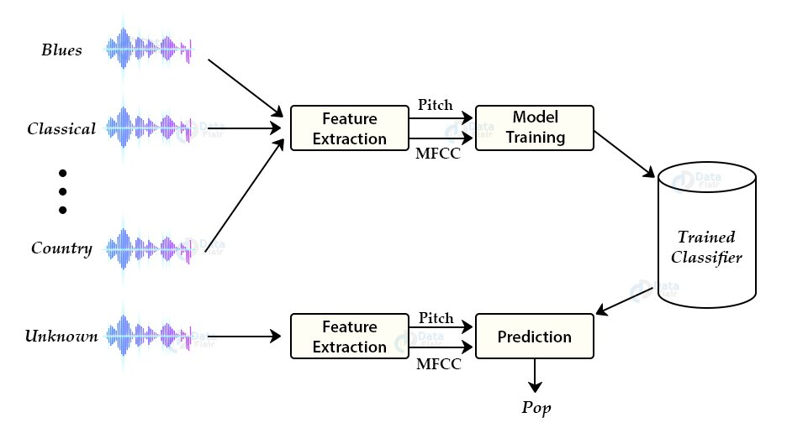

Music Genre detection a lot of online music vendors face this problem as the need to classify tons of music files into different genres for their users. I have used the approach of K-Nearest Neighbors to solve this problem.

**Why K-Nearest Neighbors**

There are various methods to perform classification on this dataset. Some of these approaches are:

* Multiclass support vector machines
* K-means clustering
* K-nearest neighbors
* Convolutional neural networks

We will use K-nearest neighbors algorithm because in various researches it has shown the best results for this problem.

K-Nearest Neighbors is a popular [machine learning algorithm](https://data-flair.training/blogs/machine-learning-algorithms/) for regression and classification. It makes predictions on data points based on their similarity measures i.e distance between them

**Tools And Software Used**

* Python_speech_features
* scipy.io.wavfile
* numpy
* os
* pickle
* random
* operator

**Feature Extraction**

The first step of any audio classification project is extract features and components from audio files. It includes identifying the linguistic content and discarding noise.

A digital image is a 2D array of pixels. Each pixel is A digital image represented as pixels and channels.

characterised by its (x, y) coordinates and its value.

**Mel Frequency Cepstral Coefficients:**

These are state-of-the-art features used in automatic speech and speech recognition studies. There are a set of steps for generation of these features:

* Since the audio signals are constantly changing, first we divide these signals into smaller frames. Each frame is around 20-40 ms long
* Then we try to identify different frequencies present in each frame
* Now, separate linguistic frequencies from the noise
* To discard the noise, it then takes discrete cosine transform (DCT) of these frequencies. Using DCT we keep only a specific sequence of frequencies that have a high probability of information.

Steps to build Music Genre Detector

1. Getting the Data Set:-

I have used the GTZAN dataset available on Kaggel.

The dataset consists of 10 genres 100 audio files, each

All being 30 seconds long in the folder named genres orignal .

1. Creating the Python Notebook
2. Importing Libraries and dependencies

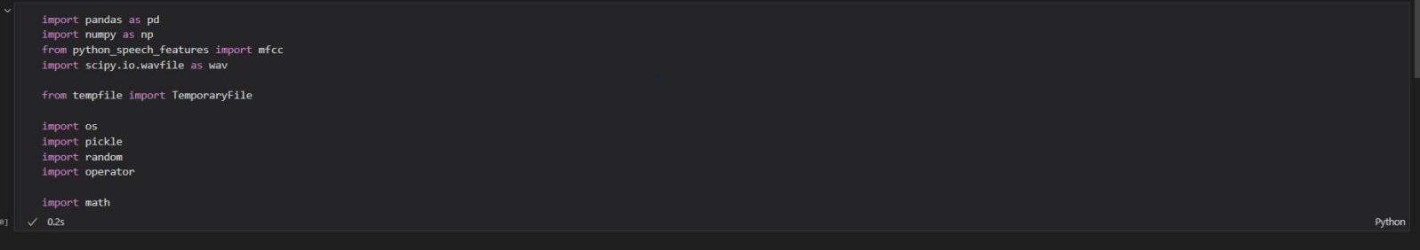

1. Define a function to get the distance between feature vectors and find neighbors:

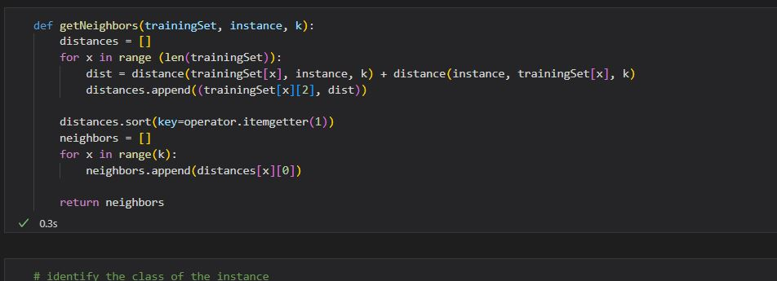

1. Identifying Nearest Neighbors:

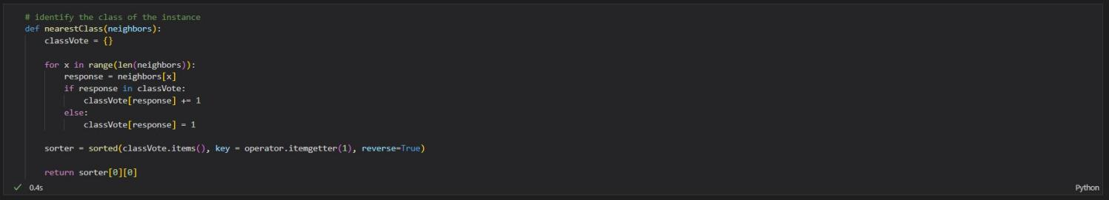

1. Define a function for model evaluation:

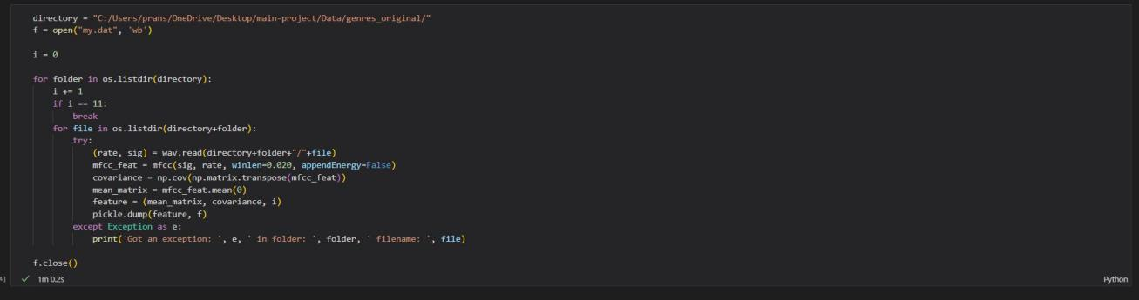

1. Train Test Split

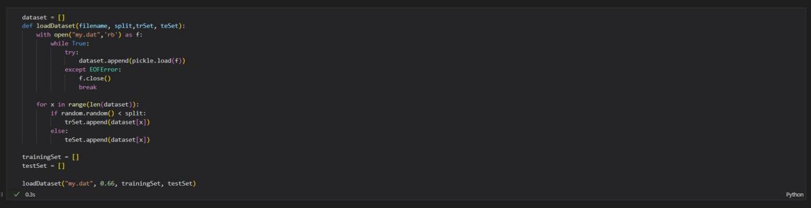

1. Finally Making Prediction using the KNN model on test data

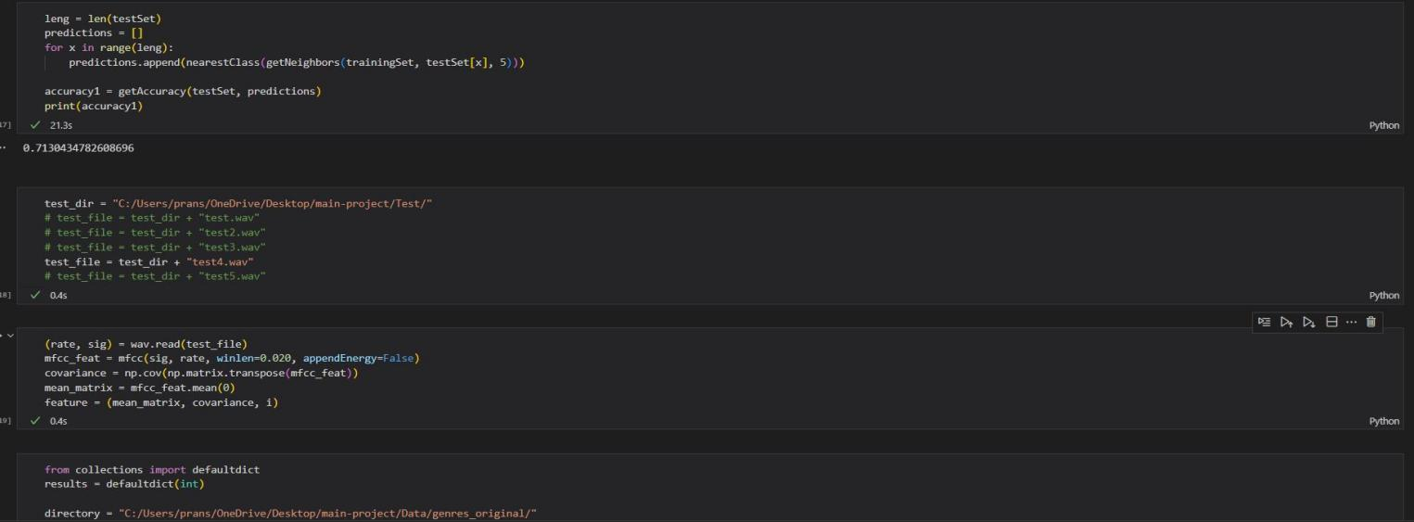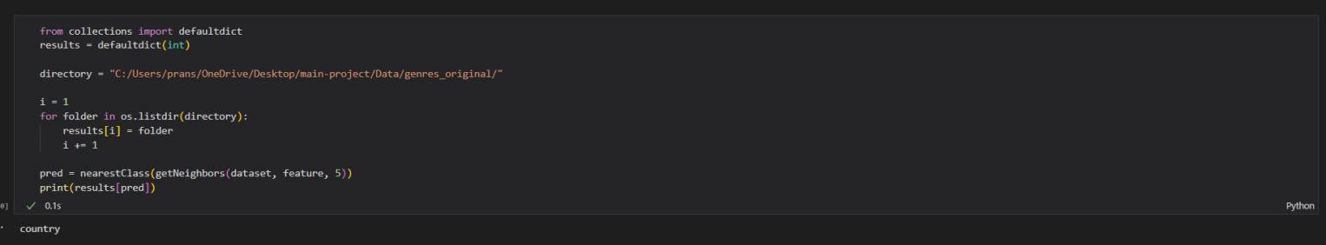

**CONCLUSION**

The completion of the project went quiet well, I learned many new thing building it .

I learned about feature extraction and noise removal from audio files , I learned a lot the working of K Nearest Neighbors machine learning algorithm. How to build a KNN model and how to make accurate predictions

I have learned the use cases of KNN prediction modals and how they are best suited for predictions like these.

**Bibliography**

I have used many resources and taken many references from the web to complete this project and to learn about K Nearest Neighbor. I found that the lectures on YouTube on the TensorFlow channel were the best to understand the core concepts of the KNN algorithm but I also found Stack Overflow and DataFlair especially helpful whenever I was stuck on a error I couldn’t debug.

* Stack Overflow
* Youtube
* Google
* Wikipedia
* DataFlairTraining